Guide to NADAbase dashboards and reports

In 2019, NADA introduced a new component in NADAbase – the NADAbase dashboards. The NADAbase dashboards provide users with an overview of their program/s activity, data quality and allows flexibility for cross sectional data analysis. Along with the introduction of the dashboards, changes were also made within the NADAbase reports section to allow for easier data extraction and analysis.

## How to navigate through the new dashboards

After logging in to NADAbase, the website will direct users to the NADAbase dashboards. There are two dashboards available, one entitled “Dashboard” and another entitled “Episode analysis.” These tabs appear at the bottom left hand side of the screen. Users will be able to switch between dashboards by clicking on the tabs.



Users are able to return to the dashboards page by clicking the home button  found at the leftmost of the menu bar.

For users who have multiple programs on NADAbase, the dashboard will show aggregated data for all programs. Users are able to specify program data by clicking on the program in “Organisation list.”

For users who have only one program in NADAbase, the dashboard will show data specific to the program.

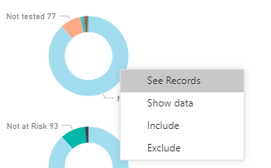

When right clicking a data element in the dashboard, users are provided options to “see records” and “show data” of the episodes that correlate to the data selected. Users are also able to “include” and ”exclude” the data element.

When clicking on different elements in the dashboard, users will find that the data will change based on the section/s clicked on in the dashboard. Multiple selections can be made by holding the “Ctrl” button on the keyboard while clicking on the data element in the dashboard.

Users are also able to export the data by clicking on the three dots icon  found in the dashboard.

Users are given the option to export summarized or underlying data, in .XLSX or .CSV format.

## Major changes in NADAbase reports

N/MDS Reports can now be found within **Episode Analysis report**. Click on the “Reports” tab and select “episode analysis report”.

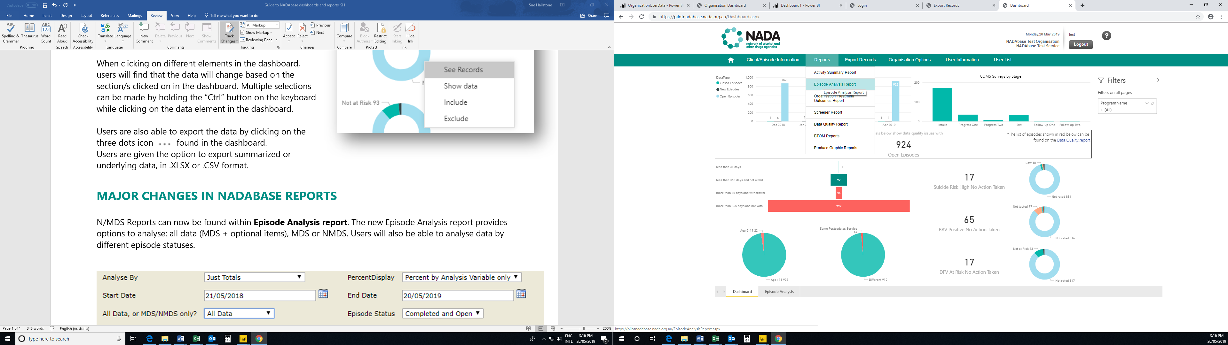

The new Episode Analysis report provides options to analyse: all data (MDS + optional items), MDS or NMDS. Users will also be able to analyse data by different episode statuses. Users will still be able to export N/MDS report by clicking the save button drop down list.

